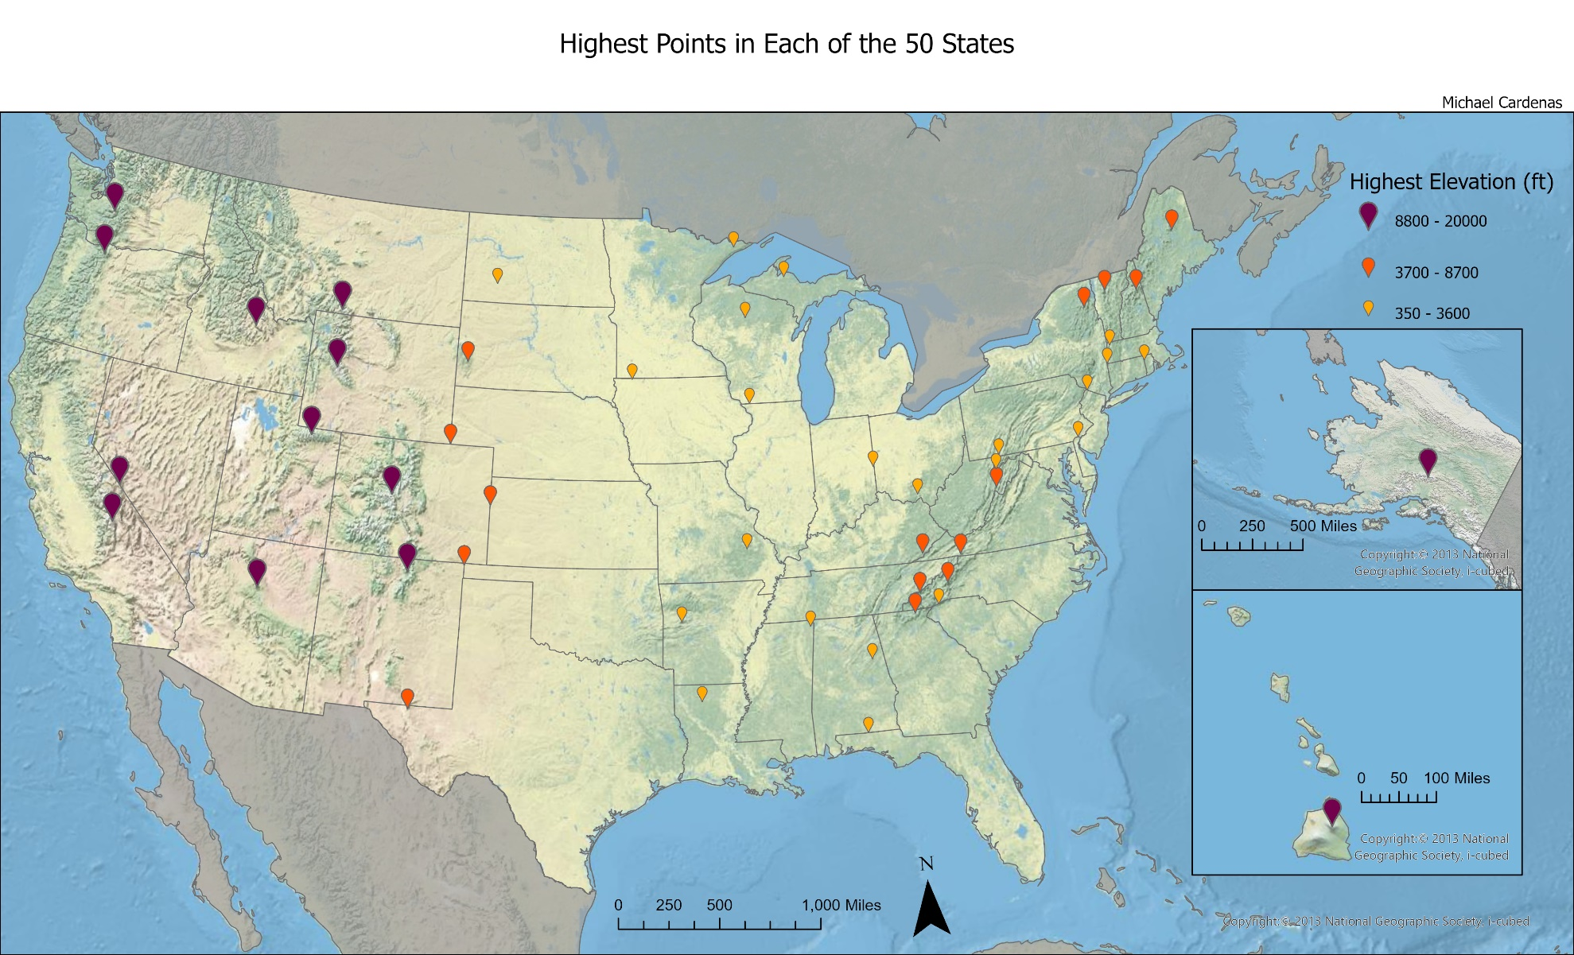

This map uses point data to mark the highest point of elevation in each of the 50 States of the United States of America. It uses an Albers Equal Area Conic projection to preserve the curvature and reduce overall distortion. Data was used from https://geology.com/state-high-points.shtml to find the names of the highest points. Unfortunately, coordinate data was not readily available and I had to rely on the Geocode Table feature in ArcGIS Pro. This method proved efficient, however, I still had to do a manual verification for each point as there were multiple demarcations for certain landmarks and ArcGIS Pro would occasionally default to the wrong one. After settling on the correct locations, I then symbolized my data using both graduated symbols and color to denote 3 classes of elevation. This created a unique visualization as it highlighted relevant geographic landmarks such as the Appalachian Mountains in the East. Another interesting feature apparent in the map is the grouping of points higher than 8,800 ft which all happen to reside in the West (Hawaii and Alaska included).